

**ASSIGNMENT**

**BUM2413**

**APPLIED STATISTICS**

**GROUP NAME**: ESTIMATOR

|  |  |  |
| --- | --- | --- |
| **NAME** | **STUDENT ID** | **SECTION** |
| HASSANUL AIMAN BIN HABBALI | CA13015 | 10G |
| NUR SYUHAIDAH BINTI ISMAIL | CB13006 | 10G |
| NUR FATEN BINTI OSMAN | AA13293 | 10G |
| NORUL HUSNA BINTI OTHMAN | CB13008 | 10G |
|  |  |  |

|  |
| --- |
| **LECTURER** |
| DR. WAN NUR SYAHIDAH BINTI WAN YUSOFF |

|  |  |
| --- | --- |
| Question number | **FOR EXAMINER USE ONLY** |
| Marks |
| 1 |  |
| 2 |  |
| 3 |  |
| Total marks |  |

**QUESTION 1**

1. Number of variables: 1

Number of random numbers: 150

Distribution: Normal distribution

Parameters: Mean = 0

Standard deviation = 1

Random seed: 1

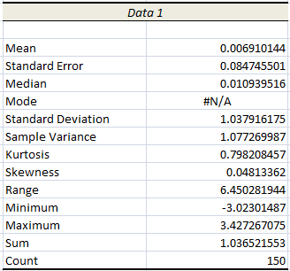

Descriptive statistic for data 1

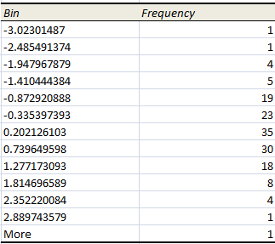

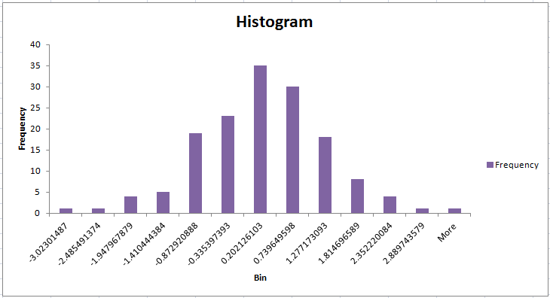

Histogram for data 1

1. Number of variables: 1

Number of random numbers: 150

Distribution: Normal distribution

Parameters:

Mean = 2

Standard deviation = 3

Random seed: 1

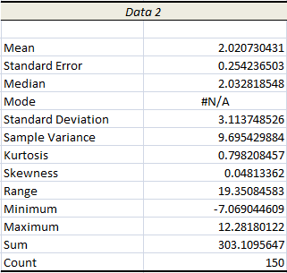

Descriptive statistic for data 2

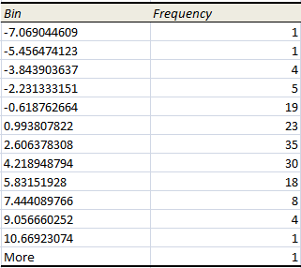

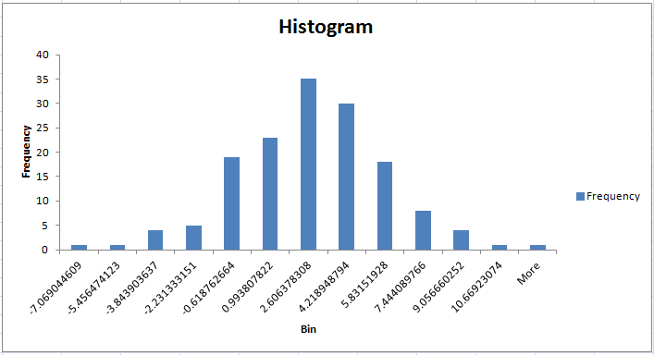

Histogram for data 2

1. **Compare and comment on the measures of central tendency and variation obtained.**

Measures of central tendency or measures of average are including the mean, median, mode and midrange. By comparing both data’s averages, Data 2 has the higher median than the median of Data 1. This median is appropriate to be used since there is no extreme small or large value of data in Data 1 or Data 2.

Measures of variation are including range, variance and standard deviation. By comparing both data’s variability, Data 2 is more variable than Data 1 due to the highest value of interquartile range.

1. **Draw histogram and identify the shape of the distribution for both data sets.**

Both histogram for Data 1 and Data 2 are left skewed shaped since mean<median<mode for both data’s.

For Data 1, mean<median<mode are 0.0<0.0109<0.2021 respectively while for Data 2, mean<median<mode are 2.0<2.0328<2.6064 respectively.

1. **Compare your result in (ii) and conclude the best of measures of central tendency and variation for the data sets.**

The best measure of central tendency is Data 2 since it has higher median than Data 1.

Variance and Standard deviation for Data 1 are 1.0773 and 1.0 respectively while for Data 2 are 9.6954 and 2.0 respectively. Since variance and standard deviation of Data 1 is smaller than variance and standard deviation of Data 2, Data 1 is the best measures of variation as it was less dispersed.

**QUESTION 2**

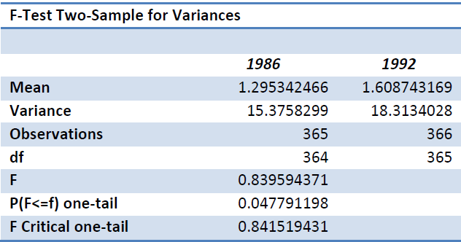

Z-Test for two sample variances

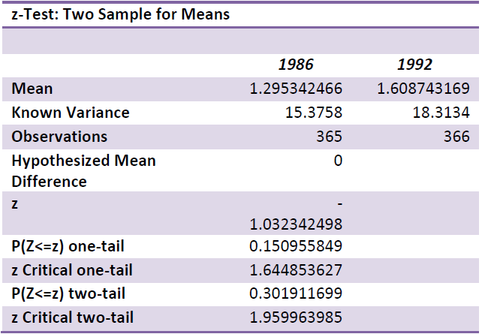

Z-Test for two sample means

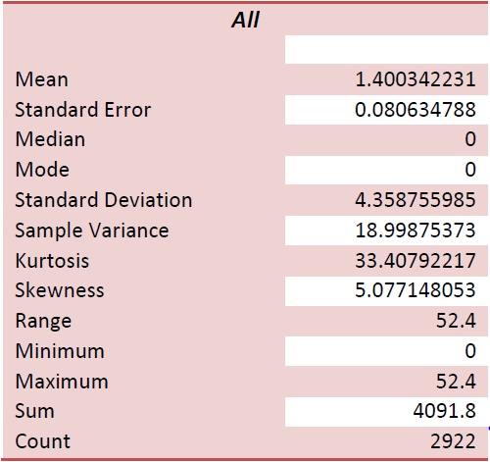

Descriptive statistic of rainfall

**QUESTION 3**

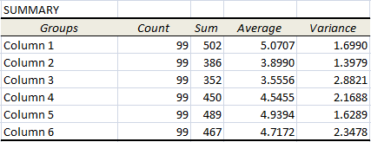

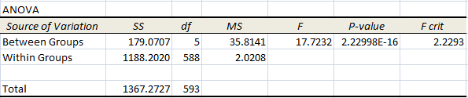

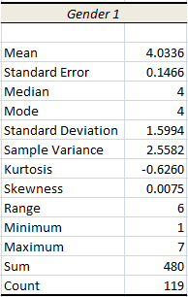 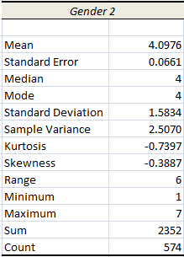

Descriptive statistic for gender 2

Descriptive statistic for gender 1

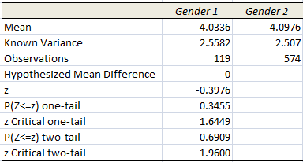

Z-Test for two sample means